TRADE OF
Pipefitting

PHASE 2

Module 4

Pipe Installation

UNIT: 5

Ancillary Piping Equipment

Produced by

In cooperation with subject matter expert:

Finbar Smith

© SOLAS 2014
Table of Contents
Unit Objective 1
Learning Outcome 2
1.0 Ancillary Piping Components 3
1.1 Identify Ancillary Piping Components 3
1.2 Types of Heat Exchangers 3
1.3 Shell and Tube Heat Exchanger 4
1.4 Plate and Frame Heat Exchanger 5
1.5 Pump Selection Criteria 7
2.0 Piping Installation 9
2.1 Design of Equipment Layout/Pipe Routing 9
2.2 Valve Selection 11
2.3 Ergonomics of Piping Design 11
`2.4 Case Study of a Centrifugal Pump Set Installation 12
3.0 Piping Systems Commissioning 13
3.1 Process Commissioning 13
3.2 Piping systems Documentation and Validation 15
Exercises 16
Additional Resources 17

Unit Objective
There are six Units in Module 4. Unit 1 focuses on Introduction to Pipe Installation and Safety, Unit 2; Piping Services, Unit 3; Electricity on Site, Unit 4; Bracket Fabrication, Unit 5; Ancillary Piping Equipment and Unit 6; Piping system assembly.
In this unit you will be introduced to good practice guidelines for installing ancillary piping equipment such as pumps, heat exchangers and valves and how best to orientate and bracket piping coming to and from this equipment.

Module 4

Pipe Installation
Unit 1

Introduction to Pipe installation and Safety
Unit 2

Piping Services
Unit 3

Electricity on Site
Unit 4

Bracket Fabrication
Unit 5

Ancillary Piping Equipment
Unit 6

Piping System Assembly

Learning Outcome
By the end of this unit each apprentice will be able to:
- Identify and describe the main ancillary piping system components
- Identify and select the correct pump for the three most common pumping applications.
- Explain why pipe lines are installed at low level, close to walls and accessible to read instruments wherever possible.
- Explain why safe access to equipment (e.g. heat exchangers and pumps) is important during commissioning, maintenance and servicing.
- List reasons why valves are used in piping systems.
- Outline the importance of bracketing pipe work around equipment to facilitate safe removal of equipment for maintenance and to ensure that piping does not strain the equipment.
- Describe the standard procedure for safe start-up and commissioning of ancillary piping equipment.
- Recognise the importance of and the need to retain and file equipment manuals and material certification.

1.0 Ancillary Piping Components

Key Learning Points
- Identify and describe the main ancillary piping system components
- Identify the purpose of heat exchangers
- Describe the operating principals of two types of heat exchangers
- Identify the important criteria for pump selection
- Evaluate 3 pumps against these selection criteria

1.1 Identify Ancillary Piping Components
Ancillary piping components are the additional items installed in a piping system such as pumps, heat exchangers, valves and instrumentation. Their requirements vary depending on the media being transported in the piping system. Module 3 unit 2 has dealt with pumps, valves and basic instrumentation so this module will examine the different type of common heat exchangers and evaluate different pumps against specific pump selection criteria.

1.2 Types of Heat Exchangers
A heat exchanger is a device built for efficient heat transfer from one medium to another. The heating or cooling media is separated from the product to be heated or cooled by a solid wall, so that they never mix. There are three primary classifications of heat exchangers according to their flow arrangement. In parallel-flow heat exchangers, the two fluids enter the exchanger at the same end, and travel in parallel to one another to the other side. In counter-flow heat exchangers the fluids enter the exchanger from opposite ends. In a cross-flow heat exchanger, the fluids travel roughly perpendicular to one another through the exchanger. The counter current design is most efficient, in that it can transfer the most heat from the heat (transfer) medium. For efficiency, heat exchangers are designed to maximize the surface area of the wall between the two fluids, while minimizing resistance to fluid flow through the exchanger. The exchanger's performance can also be affected by the addition of fins or corrugations in one or both directions, which increase surface area and may channel fluid flow or induce turbulence. We will deal the 2 most common types of heat exchangers:
- Shell and Tube Heat Exchanger
- Plate Heat Exchanger

1.3 Shell and Tube Heat Exchanger
Shell and tube heat exchangers consist of a series of tubes (see Figure 1). One set of these tubes contains the fluid that must be either heated or cooled. The second fluid runs over the tubes that are being heated or cooled so that it can either provide the heat or absorb the heat required. A set of tubes is called the tube bundle and can be made up of several types of tubes: plain, longitudinally finned, etc. Shell and Tube heat exchangers are typically used for high pressure applications (with pressures greater than 30 bar and temperatures greater than 260°C). This is because the shell and tube heat exchangers are robust due to their shape.
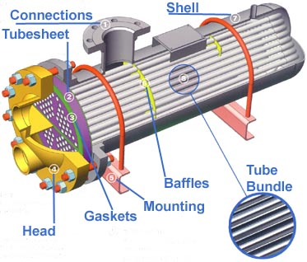
Figure 1 – Component parts of a shell and tube heat exchanger
There are several thermal design features that are to be taken into account when designing the tubes in the shell and tube heat exchangers. These include:
- Tube diameter: Using a small tube diameter makes the heat exchanger both economical and compact. However, it is more likely for the heat exchanger to foul up faster and the small size makes mechanical cleaning of the fouling difficult.
- Tube thickness: The thickness of the wall of the tubes needs to be considered for the following factors; flow rates, pressure ratings and corrosion requirements.
- Tube length: heat exchangers are usually cheaper when they have a smaller shell diameter and a long tube length which reduce the labour for manufacture. However this must be considered in conjunction with space on site to install and the need to withdraw the tube bundle for servicing.
- Tube pitch: (i.e., the centre-centre distance of adjoining tubes) needs to be considered as a large tube pitch leads to a larger overall shell diameter which leads to a more expensive heat exchanger while a narrower tube pitch can cause inefficient heat transfer.
- Tube corrugation: this is mainly used on the inner tubes to increase flow turbulence and heat transfer giving a better heat exchanger performance.
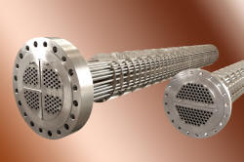
- Baffle Design: baffles are used in shell and tube heat exchangers to direct the fluid in the shell across the tube bundle. They run perpendicularly to the shell and hold the bundle, preventing the tubes from sagging over a long length. They can also prevent the tubes from vibrating. (See Figure 2)
Figure 2 – Tube bundle with baffle plates

1.4 Plate and Frame Heat Exchanger
A plate heat exchanger is composed of multiple, thin, slightly-separated plates that have very large surface areas and fluid flow passages in between for heat transfer.
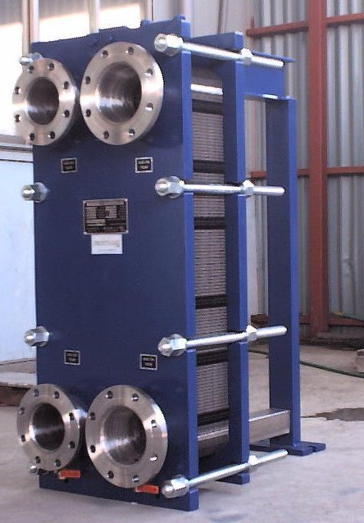
Figure 3 – Plate and frame heat exchanger with media connections on head plate
Plate heat exchangers can differ in the types of plates that are used, and in the configurations of those plates. Some plates may be formed with "chevron" (Figure 4a) or other patterns to increase flow turbulence and therefore heat transfer, where others may have machined fins and/or grooves. The gasket design (Figure 4a) allows the heating or cooling medium to flow through every second space in the plate stack and the product medium to be heated or cooled flows through the alternate spaces as can be seen in Figure 4b.
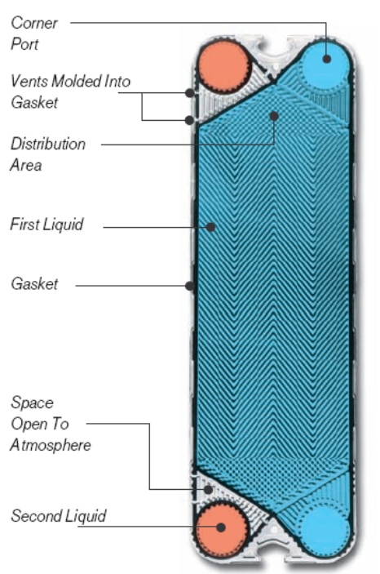
Figure 4a – Chevron plate to improve heat transfer, gasket design to direct flow
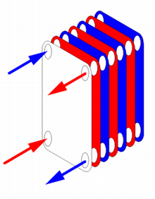
Figure 4b - Counter current flow in alternate fluid spaces
While shell and tube heat exchangers are more suited to high pressure applications plate and frame heat exchangers have the following advantages:
- Reduced installation footprint, weighs less and delivers higher performance
- Efficient operation with up to 98% heat recovery or regeneration reduces energy costs
- Low liquid hold-up enables faster reaction times to change in process
- Fluids flow counter-current to each other between the parallel passages in each pass
- Full access to both sides of the heat-transfer surface for inspection, maintenance, and cleaning
- Access is readily accomplished within the installed space of the unit, therefore there is no need to allow for additional “withdrawal” room.
- Modular design enables expansion of your heat exchanger as process requirements grow

1.5 Pump Selection Criteria
Pumps transfer liquids from one point to another by converting mechanical energy into pressure energy (head). The pressure applied to the liquid forces the fluid to flow at the required rate and to overcome friction (or head) losses in piping, valves, fittings, and process equipment. Pumping applications include constant or variable flow rate requirements, serving single or networked loads, and consisting of open loops (liquid delivery) or closed loops (recirculation systems). When selecting a pump the following points should be considered:
The pumping system designer must consider fluid properties, determine end use requirements, and understand environmental conditions.
- Pumping rate or flow rate required by the system, factors to be considered are the usage profiles of the users and the storage capacity built into the system.
- Minimum available net positive suction head (this requires knowledge of the maximum lift required and all head losses on the intake side of the pump).
- The discharge pressure required at the point of use, on top of this flow characteristics of the liquid, friction losses in the system and any head heights that the pump must overcome need to be considered.
- Characteristics of the fluid to be pumped (e.g. viscosity, temperature, solids content, corrosiveness, etc.).
- Availability of suitable power to drive the pump. In some instances in a solvent laden ATEX area, a pneumatic diaphragm pump is used as there is no electrical requirement to power the pump.
- Pump location, (e.g., indoors, outdoors, submerged, in a corrosive environment)
- Servicing / maintenance requirements of the pump and availability of spares. This will also be affected by the operating conditions of the pump and if it is operating 24/7.
Once these and perhaps other site-specific factors are known, it is possible to consult manufacturers’ literature and consider the available pumps. A major portion of this process involves consideration of trade-offs among the reliability, first cost, and operation and maintenance cost of various pumps having suitable flow/head/efficiency characteristics. Table 1 below highlights the advantages relative to each other of the following 3 pumps and why they would be selected for a particular duty:
- Centrifugal pumps
- Diaphragm pumps
- Drum pumps

Pump Characteristic | Centrifugal | Diaphragm | Drum
Flow Rate | High | Medium | Low
NPSH | Needs a positive head | Can suck liquid into pump from below | Can suck liquid into pump from below
Pressure | Normally low | Medium | High
Viscosity/ solids content | Low | High | Medium
Power supply | Electrical | Compressed Air | Electrical or Compressed air
Location | Supplier dependant | Supplier dependant | Supplier dependant
Maintenance | Low | Medium | Medium
Table 2 – Comparison of pump characteristics for pump selection

2.0 Piping Installation

Key Learning Points
- Identify why equipment and piping layouts need to be planned
- Identify the criteria which should be considered when planning equipment and piping layouts
- Identify reasons why valves are used in piping systems.
- Identify why proper piping supports are required to retain pipework and prevent piping from straining equipment.
- Identify why good ergonomics is essential for equipment and instrument layout.
- Identify the correct ancillary components of a typical centrifugal pump set.

2.1 Design of Equipment Layout/Pipe Routing
First the basis of design is established, the equipment and materials of construction selected and the Process Flow Diagram (PFD) agreed for a process piping system. The next step is to move on to a more detailed design of the system. The P&ID provides a schematic layout of the equipment, valves, instrumentation and line sizes. It is however not drawn to scale and only present the relationship or sequence between components and how they interact to control the systems functions.
The physical layout of the major items of equipment, valves and instrumentation is vital to the ergonomic operation of the plant long after the construction phase is complete. The interconnection pipework and bracketing of same is also critical to facilitate ease of access and future maintenance of the system. While this list is not exhaustive the following points should be considered when finalizing equipment and piping layouts:
- Adequate space for personnel to access system monitoring instrumentation and to access equipment to regularly inspect for signs of leaks or wear.
- Space for removal of internal components for maintenance (e.g. tube bundles from heat exchangers or agitators from the top of a vessel.)
- Thermal expansion and contraction of short runs of pipework in a plant room can in many instances be catered for by avoiding routing pipe in straight lines and introduce bends instead.
- Pipe routing should utilize the surrounding structure for support where possible. Horizontal and parallel pipe runs at different elevations should be spaced for branch connections and also for independent pipe supports.
- Sufficient and well designed bracketing should ensure that no undue stresses or forces are transmitted to system equipment which may cause premature failure of bearings etc. Supports are also important to retain pipework and facilitate ease of removal of equipment for servicing.
- Consideration should be given to other trades when installing pipe and should be coordinated to accommodate electrical conduit requirements, civil requirements for drains and clearances for pipe insulation where required.
The layout of equipment and pipe routing is greatly aided by the use of 3D modeling software (see Figure 5a and 5b) which allows piping designers to visualize the complete installation and zoom in on congested areas to check for clashes of valves and instrumentation. Extensive component libraries allow the designer to quickly import standard components to compile the system model which can then perform static and dynamic stress analyses on pipe and equipment and indicate the best positions for anchors and supports. Individual isometrics can be exported with bills of materials for purchasing to procure the necessary materials and the more sophisticated packages can be linked with ERP systems to provide a complete costing tool.
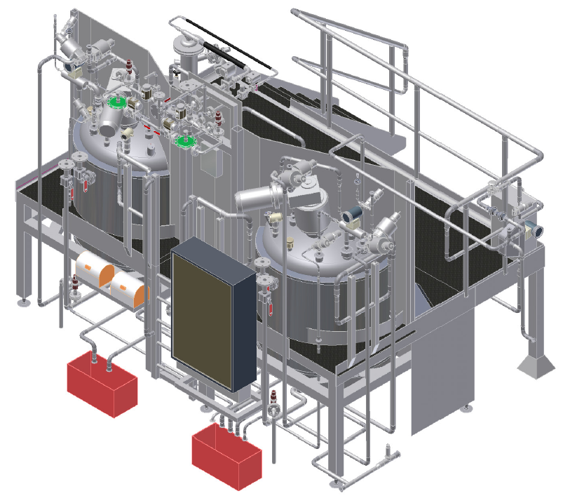
Figure 5a – 3D model of equipment and pipe layout for pharmaceutical process system
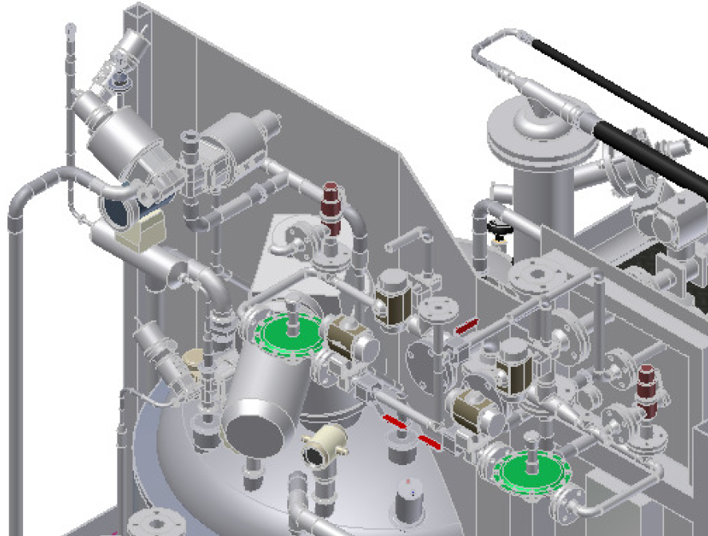
Figure 5b – Close up of 3D model for pipes valves and instruments

2.2 Valve Selection
For liquid piping systems, valves are the controlling element. Valves are used to isolate equipment and piping systems, regulate flow, prevent backflow, and regulate and relieve pressure. The most suitable valve must be carefully selected for the piping system. The minimum design or selection parameters for the valve most suitable for an application are the following: size, material of construction, pressure and temperature ratings, and end connections. In addition, if the valve is to be used for control purposes, additional parameters must be defined. These parameters include: method of operation, maximum and minimum flow capacity requirement, pressure drop during normal flowing conditions, pressure drop at shutoff, and maximum and minimum inlet pressure at the valve. These parameters are met by selecting body styles, material of construction, seats, packing, end connections, operators and supports.

2.3 Ergonomics of Piping Design
While construction schedule and costs drive mechanical contractors to install piping systems quickly it must be remembered that the final system will be operated for many years in the future. For this reason it is critical that proper consideration be given to the ergonomic layout of the equipment and instrumentation so as to ensure that the operator can comfortably operate the system. Simple things such as gauges at an ergonomic height, orientated in an upright position and with readable sized scales can make the monitoring and recording of information so much easier. Ease of access to equipment for periodic inspections and checking for leaks will ensure that the plant is well cared for and well maintained. Space for removing equipment

`2.4 Case Study of a Centrifugal Pump Set Installation
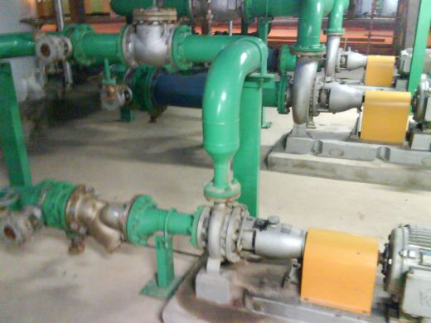
Figure 6 – Typical centrifugal pump and ancillary components installation
Pump
Check valve
Strainer
Isolation Valves
Figure 6 above shows the components utilized on a typical centrifugal pump installation and the following gives a brief outline on why they are required for an effective centrifugal pump set.
Isolation Valves
Pumps often need repairs. Sometimes mechanical seal leakages occur. Pump bearings also need replacement. In order to carry out such repairs pump needs to isolated. It should have no process fluid so that it can be worked upon. Installing isolation valves ensures that no liquid flows towards the pump due to gravity from either upstream or downstream of pump.
Strainer
A strainer is a 'filter' that prevents undesirable solid particles to flow upstream and clog the equipments. A strainer contains a mesh that prevents the particles from flowing through it. Two main types of strainers are: y-type strainers and basket strainers. Y-type strainers (shown in figure 6) are used for relatively clean fluids while basket type strainers are used where greater amounts of particles are present. When running a pump for the first time it is vital that the strainer is checked on a regular basis as it will often clog up with construction dirt and debris left over from the system fabrication.
Check valve
Check valves are used to prevent backflow in the system, if a pump was to malfunction the fluid which has been pumped upstream would try to flow back towards the pump. In order to stop this from happening a check valve is used.

3.0 Piping Systems Commissioning

Key Learning Points
- Identify the requirements for safe start-up and commissioning of ancillary piping equipment.
- Identify the requirement to collate equipment manuals and material certification for system validation.

3.1 Process Commissioning
Process commissioning occurs between the time construction is complete and plant startup commences. During this period process commissioning personnel are occupied with the task of ensuring the facilities have been constructed and assembled according to the engineering design and the equipment manufacturer’s directions. The objective is to ensure that the equipment has been properly installed and is ready to receive process materials and operate as originally conceived.
While this list is not exhaustive the following points should be considered when preparing for safe start-up and commissioning of ancillary piping equipment:
- Commissioning plan and procedures must be prepared that describe in detail how the various tests will be conducted and evaluated.
- A commissioning team assembled of experienced managers, engineers, plant operators and fitters (these may be from the mechanical contractor who installed the facility) acting as support staff.
- The process commissioning procedures must also describe safety precautions that must be taken before, during, and after the commissioning process.
- The detailed commissioning plan should synchronize the turnover of process units from the mechanical contractor to the commissioning team.
- Before the commissioning team will accept any packages the following should be signed off and available :
  - DQ and basis of design for each of the systems in the facility
  - P&ID System walk-downs
  - Flushing and pressure test, test packs.
  - Chemical cleaning and passivation
  - IQ and OQ documentation
  - Equipment suppliers documentation and Operation and maintenance (O&M) manuals
- Project planning software, should be used to organize and control the commissioning process, so that resources can be scheduled and deployed in the most effective way to ensure that all elements are eventually commissioned and declared operable.
- It is essential that there is accurate progress reporting and feed back from the field, as more often than not the commissioning of the next system is dependant on the first being a success.
Just as with the actual construction of the process facility, process commissioning is a complex activity covering all aspects of the newly constructed facilities.
- Each element of the process unit is examined and tested.
- Process control valves must be stroked,
- Controller tuning coefficients must be checked.
- Sensors and analyzers must be calibrated
- Relief valve settings must be checked,
- Piping and equipment is often hydrostatically tested or tested with inert gas again to find and eliminate any leaks which may occur from final assembly or fitting of sensitive instruments which were removed for the system pressure test.
- Strainers, filters and tramp metal collectors must be installed at critical locations in the piping system to prevent damage to pumps and control valves.
Coordination between trades is essential and tasks such as the following will need two or more trades to verify:
- Insulation must be inspected and steam tracing tested.
- Electrical connections must be checked and electrical equipment tested where and when it can be done safely.
- Rotating equipment must be checked for alignment and manually rotated to ensure there are no interferences. Electrical motors need to be run to ensure the connections are correctly installed and that the motor rotates in the correct direction.
Should problems develop during the startup phase, written plans and procedures should be in place to empty each process unit in a safe and environmentally compliant manner so that whatever problems occurred can be fixed. Any defects found during he commissioning process must be corrected by the contractor before the process unit commissioning can be declared as complete.
A major part of process commissioning is in preparing the operating instructions for the startup of the process. The procedures for a newly constructed plant often differ from the procedures that would be placed in service after a successful production campaign. In the case of a newly constructed plant, the procedure may call for each upstream unit to be brought up to operating temperatures and pressure and held for a period of time to validate the integrity of the unit before process material is allowed to flow to the next downstream unit.

3.2 Piping systems Documentation and Validation
More and more industries have placed an increasing emphasis on quality standards and documentation in order to expedite their approval process for either their own internal corporate quality requirements or for external bodies such as the IMB (Irish Medicines Board) or the FDA (United States Food and Drug Administration). The approval process requires that the facility in which a new product or drug is produced must be designed, constructed and commissioned so that it meets the criteria for process validation.
Validation is the action of proving, in accordance with the principles of GMP (Good Manufacturing Practice), that any procedure, process, equipment, material activity or system consistently leads to the expected results. Documented evidence provides a high degree of assurance that a specific system, equipment or process will consistently produce a product meeting its pre-determined specifications and quality attributes. To put it simply, validation is nothing more than proving that a process actually works.
Failure to achieve validation on the first attempt can be very costly to the facility owner, so maintaining quality from the design phase throughout the construction process is essential. To this end the pipe fitter / welder can play a major part in ensuring the following documents are maintained and collated in a controlled fashion:
- Collecting and filing material certification for goods received on site
- Collecting and filing equipment documentation and manuals for equipment received on site
- Use the correct tacking and weld procedures and ensure that all personnel welder qualifications are kept current.
- Accurate maintenance of weld record sheets and isometrics during the fabrication and installation phase.
- Co-ordinate with inspection companies to ensure weld inspection is maintained at or above the required % level or that all welds are examined where 100% traceability is required.
- Ensure test packs are completed in the required format and signed off and witnessed by the relevant personnel
- Ensure any re-routings or changes in drawings are recorded properly and that the information is relayed through the proper channels to ensure accurate “As-built” drawings are handed over to the client.

Exercises
- Identify 2 advantages and 2 disadvantages of a plate and frame heat exchanger
- Identify 2 reasons as to why a centrifugal pump would be chosen before an air operated diaphragm pump
- List 3 reasons why good equipment and piping layout planning is vital for the operation of a facility after handover.
- Dismantle and examine a pipe strainer and explain how it protects equipment upstream.
- Identify 3 ways how a pipe fitter can contribute to the documentation process for system validation.

Additional Resources
Title | Author | Ref. Code
The Induction Book, “Code of Behaviour & Health & Safety Guidelines” | SOLAS
Basic Welding and Fabrication | W Kenyon | ISBN 0-582-00536-L
Fundamentals of Fabrication and Welding Engineering | FJM Smith | ISBN 0-582-09799-1
Workshop processes, practices and materials, 3rd edition, Elsevier Science & Technology | Black, Bruce J 2004 | ISBN-13: 9780750660730
New Engineering Technology | Lawrence Smyth & Liam Hennessy | ISBN 086 1674480

Videos:
- Understanding welding fumes
- Welder on Site…Be Aware (Vocam)
- Powered hand tool safety (Vocam)
- Industrial Ergonomics (Vocam)
Available from:
Vocam Ireland
Circle Organisation Ltd
Friar Street, Thurles, Co Tipperary, Ireland
Tel: +353 504 24666

Castleforbes House
Castleforbes Road
Dublin 1

